**PALM PATTERN. RECOGNITION USING FEATURE DETECTION**

**A PROJECT REPORT**

**Submitted by**

|  |  |
| --- | --- |
| **S.JAYAMATHAN** | **(1302038)** |
| **S.R.KISHORR** | **(1302046)** |
| **T. DHEENA DHAYALAN** | **(1302058)** |

### *in partial fulfilment for the award of the degree*

### *of*

**BACHELOR OF ENGINEERING**

in

**ELECTRONICS AND COMMUNICATION ENGINEERING**

**SRI RAMAKRISHNA ENGINEERING COLLEGE**

**(An Autonomous Institution)**

**COIMBATORE-641022**

**ANNA UNIVERSITY: CHENNAI-600025**

**APRIL - 2017**

**SRI RAMAKRISHNA ENGINEERING COLLEGE**

**[Educational Service: SNR Sons Charitable Trust]**_

[Autonomous Institution, Accredited by NAAC with ‘A’ Grade]_

[Approved by AICTE and Permanently Affiliated to Anna University,Chennai]_

[ISO 9001-2008 Certified and all eligible programmes Accredited by NBA]_

VATTAMALAIPALAYAM, N.G.G.O. COLONY POST,

**COIMBATORE – 641022.**

# BONAFIDE CERTIFICATE

Certified that this project report **“PALM PATTERN RECOGNITION USING FEATURE DETECTION”** is the bonafide work of **S. JAYAMATHAN, S.R. KISHORR** and **T. DHEENA DHAYALAN** who carried out the project work under my supervision.

#### SIGNATURE SIGNATURE

#### Dr.M.JAGADEESWARI, M.E.,Ph.D., Ms.V.SANGEETHA, M.E.,

#### HEAD OF THE DEPARTMENT SUPERVISIOR

**Assistant Professor (Sr. G)**

#### Department of Electronics and Department of Electronics and Communication Engineering, Communication Engineering,

Sri Ramakrishna Engineering College, Sri Ramakrishna Engineering College,

Coimbatore - 641022. Coimbatore -641022.

**Submitted for viva-voce Examination held on _____________**

**INTERNAL EXAMINER EXTERNAL EXAMINER**

**ACKNOWLEDGEMENT**

First and foremost, we place this project work on the feet of **GOD ALMIGHTY** who is the power of strength in each step of progress towards the successful completion of this project

We express our heartfelt thanks to our esteemed Managing Trustee, **Shri.R.Vijayakumhar, B.E, M.S., M.B.A** and joint Managing Trustee **Shri.D.Lakshminarayanaswamy, B.Tech, M.B.A,** for providing us with plenty of facilities to complete this project.

We are thankful to our beloved **Dr.A.Ebenezer Jeyakumar, M.E., Ph.D.,** Director (Academics)S.N.R Sons Charitable Trust, Coimbatore for his great inspiration with blessings.

We are highly indebted to **Dr. N.R.Alamelu**, **B.E(HONS)., M.E., Ph.D.,** Principal, Sri Ramakrishna Engineering College, Coimbatore for her support and facilities.

We express our gratitude and obligation to our respected Head of the Department of Electronics and Communication Engineering, **Dr.M.Jagadeeswari, M.E., Ph.D.,** for giving us the opportunity to display our professional skills through this project.

We are greatly thankful to our project coordinator **Dr.S.Jayanthy, M.E., Ph.D.,** and our guide **Ms.V.Sangeetha, M.E.,** Assistant Professor (Sr.G), Department of Electronics and Communication Engineering, for her valuable guidance and motivation, which helped us to complete this project on time.

We thank all our teaching and non-teaching staff members of the Electronics and Communication Department. Also, we would like to record our deepest gratitude to our parents for their constant encouragement and support which motivated us to complete our project.

**ABSTRACT**

Palm pattern recognition is a technique of [biometric](https://en.wikipedia.org/wiki/Biometrics) [identification](https://en.wikipedia.org/wiki/Forensic_identification) through the analysis of the patterns of [blood vessels](https://en.wikipedia.org/wiki/Blood_vessel) visible from the surface of the skin. The texture of the palm pattern of different individuals has been proven to be distinctive even among identical twins. Initially the palm images are preprocessed to select the region of interest for palm pattern extraction. Here, local thresholding is used to extract the palm pattern for its texture analysis. Scale invariant feature transform algorithm is used to compare the images and recognize the pattern. To effective person identification palm pattern recognition implemented by feature detection. Scale Invariant Feature Transform (SIFT) is based on fast robust local feature detector used in computer vision such as feature detection. It is combination of fast key point detector and visual descriptor binary robust independent element features. Using this method palm pattern can be acquired, matched, recognized, authenticated which provides fast and great substitute to ORB. ORB key point detector have proven efficient in number of application such as recognition of objects, stitching of images and visual mapping. However a large computational burden is imposed in real time systems. Scale Invariant Feature Transform (SIFT) act as a best replacement with lower computational cost. For this purpose we apply Scale Invariant Feature Transform (SIFT) are applied on palm pattern images and their matching evaluation parameters are computed.

**TABLE OF CONTENT**

|  |  |  |
| --- | --- | --- |
| **CHAPTERNO.** | **TITLE** | **PAGE NO.** |
|  | **ABSTRACT** | **iv** |
|  | **LIST OF FIGURES** | **viii** |
|  | **LIST OF ABBREVIATIONS** | **ix** |
| **1** | **INTRODUCTION** | **1** |
|  | 1.1 PROJECT OVERVIEW | 1 |
|  | 1.2 CHAPTER ORGANISATION | 1 |
| **2** | **LITERATURE SURVEY** | **2** |
|  | 2.1 INTRODUCTION | 2 |
|  | 2.2 BACKGROUND WORK | 3 |
|  | 2.3 SUMMARY | 6 |
| **3** | **IMAGE PROCESSING**  3.1 INTRODUCTION | **7**  7 |
|  | 3.2ALGORITHM | 8 |
|  | 3.2.1 SIFT  3.2.2 ORB  3.2.2.1FAST KEYPOINT ORIENTATION  3.2.2.2FAST DETECTOR  3.2.2.3ORIENTATION BY INTENSITY  3.3 ALGORITHM IMPLEMENTATION  3.3.1SEGMENTATION OF HAND SHAPE  3.3.2 ROI EXTRACTION  3.3.3KEYPOINT DETECTION  3.3.4MATCHING IMAGE  3.4 SUMMARY | 8  13  14  15  15  15  15  16  16  17  17 |
| **4** | **SOFTWARE IMPLEMENTATIO** | **18** |
|  | 4.1 OPEN CV  4.1.1 CROSS PLATFORM  4.1.2 APPLICATION | 18  20  20 |
|  | 4.2 PYTHON  4.3 OPEN CV – PYTHON  4.4 INSTALLING OPEN CV – PYTHON IN WINDOWS  4.4.1 INSTALLING FROM PREBUILT BINARIES | 21  22  23  23 |
|  | 4.4.2 BUILDING OPEN CV FROM SOURCE  4.5 SIFT IN OPEN CV  4.6 ORB IN OPEN CV  4.7 SUMMARY | 23  30  32  34 |
| **5** | **EXPERIMENTAL RESULTS** | **35** |
| **6** | **CONCLUSION AND FUTURE WORK**  **REFERENCES**  **APPENDIX** | **45** |
|  |  |  |

**LIST OF FIGURES**

|  |  |  |
| --- | --- | --- |
| **FIGURE NO** | **TITLE** | **PAGENO** |
| 3.1 | SIFT GAUSSIAN PYRAMID | 10 |
| 3.2 | SIFT KEY POINT REPRESENTATION | 11 |
| 4.1 | FILLING THE FIELDS | 24 |
| 4.2 | SELECTING A COMPILER | 25 |
| 4.3 | SELECTING APPROPRIATE WITH FIELDS | 26 |
| 4.4 | SELECTING BUILD FIELDS | 27 |
| 4.5 | SELECTING THE REQUIRED FIELDS FOR OPEN CV | 28 |
| 4.6 | SELECTING ENABLE FIELDS | 29 |
| 4.7 | FILLED PYTHON FIELD | 29 |
| 4.8 | INSTALLING OPEN CV – PYTHON | 30 |
| 4.9 | KEY POINTS DETECTION USING SIFT | 32 |
| 4.10 | KEY POINT DETECTION USING ORB | 34 |
|  |  |  |

**LIST OF ABBREVIATIONS**

|  |  |
| --- | --- |
|  |  |
| BRIEF | Binary Robust Independent Elementary Feature |
| IDE | Integrated Development Environment |
| Open CV | Open Computer Vision |
| ORB | Oriented FAST and Rotated BRIEF |
| ROI | Region of interest |
| SIFT | Scale Invariant Feature Transform |
|  |  |
|  |  |
|  |  |
|  |  |
|  |  |

**CHAPTER 1**

**INTRODUCTION**

**1.1 PROJECT OVERVIEW**

The main aim of this project is to use palm patterns for bio metric authentication and recognition of individuals. The main contribution is to develop low cost, low computational burden and highly efficient biometric system. The input images are initially converted from BGR images to grayscale images. The region of interest is detected in these images. From those ROI key point detection is done. After key point detection SIFT algorithm is performed on target images. Reference samples are compared with target images. This comparison is based on distance measurements between key points. Based on the comparison the images are processed and those images are used for person authentication and identification. In addition to this ORB algorithm is performed on those images and experimental comparison is done between ORB and SIFT algorithms. This experimental comparison helps to identify accuracy, computational burden and efficiency between these two algorithms. SIFT algorithm is highly applicable and easily available where as ORB is useful in real time application with less computational burden but on the sacrifice of image accuracy.

**1.2 CHAPTER ORGANISATION**

This project focuses on implementation of a image processing which processes the image

* Chapter 2 Provides the literature review of the project
* Chapter 3 Describes about image processing ‘
* Chapter 4 Software description of the project
* Chapter 5 Summarizes the experimental results
* Chapter 6 Discusses the conclusion and future work

**CHAPTER 2**

**LITERATURE SURVEY**

**2.1 INTRODUCTION**

Biometrics refers to metrics related to human characteristics. Biometrics authentication (or realistic authentication)is used in computer science as a form of identification and [access control](https://en.wikipedia.org/wiki/Access_control). It is also used to identify individuals in groups that are under [surveillance](https://en.wikipedia.org/wiki/Surveillance).

Biometric identifiers are then distinctive, measurable characteristics used to label and describe individuals. Biometric identifiers are often categorized as physiological versus behavioral characteristics. Physiological characteristics are related to the shape of the body. Examples include, but are not limited to [fingerprint](https://en.wikipedia.org/wiki/Fingerprint), palm veins, [face recognition](https://en.wikipedia.org/wiki/Facial_recognition_system), [DNA](https://en.wikipedia.org/wiki/DNA), [palm print](https://en.wikipedia.org/wiki/Palm_print), [hand geometry](https://en.wikipedia.org/wiki/Hand_geometry), [iris recognition](https://en.wikipedia.org/wiki/Iris_recognition), [retina](https://en.wikipedia.org/wiki/Retinal_scan) and odour/scent. Behavioral characteristics are related to the pattern of behavior of a person, including but not limited to [typing rhythm](https://en.wikipedia.org/wiki/Keystroke_dynamics), [gait](https://en.wikipedia.org/wiki/Gait_analysis), and [voice](https://en.wikipedia.org/wiki/Speaker_recognition). Some researchers have coined the term b4ehaviometrics to describe the latter class of biometrics. Since biometric identifiers are unique to individuals, they are more reliable in verifying identity than token and knowledge-based methods; however, the collection of biometric identifiers raises privacy concerns about the ultimate use of this information.

Many different aspects of human physiology, chemistry or behavior can be used for biometric authentication. The selection of a particular biometric for use in a specific application involves a weighting of several factors. Proper biometric use is very application dependent. Certain biometrics will be better than others based on the required levels of convenience and security. No single biometric will meet all the requirements of every possible application.

**2.2 BACKGROUND WORKS**

A paper published by Sahar Bayoumi, et.al[1], introduced a new methodology for Palm Vein recognition by adopting PCA. In order to capture Palm vein images of dorsa, infrared camera have been used. PCA is applied to extract distinct features which are generated as vector of features. A matching process is then applied to find the best match from the dataset to recognize and authenticate the person. Experiments show that there system is able to recognize human with accuracy 85% in real-time based on supervised recognition. Y Haoet. Al[2] proposed a new contactless palm print authentication system by using feature level image registration and pixel-level fusion for improving the verification performance. The major steps involved are:

• A sequence of multi-spectral hand images is obtained

• Pre-process each image independently to achieve coarse localization of ROIs

• Each sequence of images are further refined through feature level image registration

• Fused image is produced as output.

The main advantage is that, it can be used for pixel-level fusion of multispectral images and Fast recognition possible as no extra memory consumption required.

Drawback of this method is that, it is not efficient while using image registration.

Two new contact-free palm vein representations, namely Hessian phase information from the enhanced palm vein patterns during the preprocessing stage and the orientation encoding of palm vein line-like patterns using localized Radon transform where proposed by Yingbo Zhou[3], Ajay Kumar which have been used for Forensic, Military based and online business applications. CASIA Dataset is used for analysis. This method helped to enhance the efficiency of feature extraction of palm vein patterns. The main steps involved are:

• Preprocessing stage which includes ROI segmentation and Image enhancement

• Feature extraction and representation using Hessian, LRT, LPP and ordinal representation

• Matching score generation using cosine similarity.

• Score combination using the four representations.

Z.khanet.al[4] proposed a Contour Code, a novel orientation and binary hash table based encoding for palm print recognition. It facilitates simultaneous matching to the database and score level fusion of the multispectral bands in a single step. Main advantage includes normalization of scores which is not required before fusion and this single methodology can be used for the extraction of both the line and vein features. Major steps involved are :

• Preprocessing hand images

• Identifying region of interest

• Contour Code representation derived using a two stage filtering approach to extract only directional features

• Contour Code which is binarized into an efficient hash table structure.

Multispectral palm print verification results on the Poly U and CASIA databases show that the Contour Code achieves an EER reduction upto 50%, compared to state-of-the-art methods.

An automated finger-vein verification system using the mean curvature was introduced by Lin Zhang et al[5]. The mean curvature at a point on a surface is, roughly speaking, the mean of the surface curvatures in all directions. Treating the intensity surface of an image as a geometric object, this method views the vein pattern as valley-like structures. By a valley-like structure mean a long channel, like a gutter, whose cross-section forms the shape of U or V. Its inversion is referred to as a ridge like structure. The set of points with negative mean curvature is determined to be a valley-like structure. The mean curvature has been used in other applications for determining the degree of ridge or valley-likeness.

A promising new approach based on local texture patterns is proposed in. First, operators and histograms of multi-scale Local Binary Patterns (LBPs) are investigated in order to identify new efficient descriptors for palm vein patterns. Novel higher-order local pattern descriptors based on Local Derivative Pattern (LDP ) histograms are then investigated for palm vein description. Both feature extraction methods are compared and evaluated in the framework of verification and identification tasks. Extensive experiments done by L.Mirmohamdsadeghi et.al[6] on CASIA Multi-Spectral Palm print Image Database Vl.O(CASIA database) identify the LBP and LDP descriptors which are better adapted to palm vein texture. Tests on the CASIA datasets also show that the best adapted LDP descriptors consistently outperform their LBP counterparts in both palm vein verification and identification.

A paper published by J.C. Lee[7], developed a reliable and robust palm vein identification system for real-time personal identification by applying a low-cost NIR CCD camera-based palm vein device to capture the palm vein images. A preprocessing algorithm extracts a rectangle area (ROI) from a palm vein image for feature extraction. To represent a low-resolution palm vein image and match different palm vein images, the use of 2-D Gabor filter is extended to represent a palm vein image using its texture feature, and apply a normalized hamming distance for the matching measurement. In addition, a new technique is proposed called directional coding to code the palm vein features in two bits representation. This method represents the biometric features in bit string format which enable speedy matching and convenient storage. Using this representation, the total size of a palm vein feature is reduced to 2520 bits. In palm vein database of 4,140 palm vein images from 207 different palms, the achievement of high recognition rate (greater than 99%), and its equal error rate is 0.4%, which is comparable with all other hand-based biometrics, such as hand geometry and fingerprint verification.

There are different palm vein extraction techniques using texture descriptors. Most commonly used method is using Local Binary Pattern. It extracts contrast information only. Another texture based descriptor called LDP extracts directional information. In order to increase the efficiency, Local directional texture Pattern descriptor is used, which extracts both directional as well as contrast information.

**2.3 SUMMARY**

This Chapter deals with the different techniques to improve the Open CV software in various aspects. The disadvantages in the existing system should overcome in the proposed design.

**CHAPTER 3**

**IMAGE PROCESSING**

**3.1 INTRODUCTION**

Image processing is a method to perform some operations on a image, in order to get an enhanced image or to extract some useful information in it. It is a type of signal processing in which input is an image and output may be image or characteristics or features associated with that image. Now a days, image processing is among rapidly growing technologies. It forms core research area within engineering and computer science disciplines too.

Image processing basically includes the following three steps:

* Importing the image via image acquisition tools;
* Analyzing and manipulating the image;
* Output in which result can be altered image or report that is based on image analysis.

The purpose of image processing is divided into five groups.

They are,

1. Visualization- Observe the objects that are not visible.
2. Image sharpening ad restoration- To create a better image.
3. Image retrieval- Seek for the image of interest.
4. Measurement of pattern- Measures various objects in an image.
5. Image recognition- Distinguish the object in an image.

Image processing is processing of images using mathematical operations by using any form of [signal processing](https://en.wikipedia.org/wiki/Signal_processing) for which the input is an image, a series of images, or a video, such as a [photograph](https://en.wikipedia.org/wiki/Photograph) or [video frame](https://en.wikipedia.org/wiki/Video_frame); the output of image processing may be either an image or a set of characteristics or [parameters](https://en.wikipedia.org/wiki/Parameter) related to the image. Most image-processing techniques involve treating the image as a [two-dimensional](https://en.wikipedia.org/wiki/Two-dimensional) [signal](https://en.wikipedia.org/wiki/Signal_(electrical_engineering)) and applying standard signal-processing techniques to it. Images are also processed as [three-dimensional](https://en.wikipedia.org/wiki/Three-dimensional) signals with the third-dimension being time or the z-axis.

Image processing usually refers to [digital image processing](https://en.wikipedia.org/wiki/Digital_image_processing), but [optical](https://en.wikipedia.org/wiki/Optical_engineering) and [analog image processing](https://en.wikipedia.org/wiki/Analog_image_processing) also are possible. This article is about general techniques that apply to all of them. The acquisition of images (producing the input image in the first place) is referred to as imaging.

Closely related to image processing are [computer graphics](https://en.wikipedia.org/wiki/Computer_graphics) and [computer vision](https://en.wikipedia.org/wiki/Computer_vision). In computer graphics, images are manually made from physical models of objects, environments, and lighting, instead of being acquired (via imaging devices such as cameras) from natural scenes, as in most animated movies. Computer vision, on the other hand, is often considered high-level image processing out of which a machine/computer/software intends to decipher the physical contents of an image or a sequence of images

In modern sciences and technologies, images also gain much broader scopes due to the ever growing importance of [scientific visualization](https://en.wikipedia.org/wiki/Scientific_visualization) (of often large-scale complex scientific/experimental data). Examples include [microarray](https://en.wikipedia.org/wiki/Microarray) data in genetic research, or real-time multi-asset portfolio trading in finance.

**3.2 ALGORITHM**

**3.2.1 SCALE INVARIANT FEATURE TRANSOFRM ALGORITHM (SIFT)**

Scale-invariant feature transform (SIFT) is an algorithm in [computer vision](https://en.wikipedia.org/wiki/Computer_vision) to detect and describe local features in images. SIFT can robustly identify objects even among clutter and under partial occlusion, because the SIFT feature descriptor is invariant to [uniform scaling](https://en.wikipedia.org/wiki/Scaling_(geometry)), [orientation](https://en.wikipedia.org/wiki/Orientation_(geometry)), and partially invariant to [affine distortion](https://en.wikipedia.org/wiki/Affine_transformation) and illumination changes. This section summarizes Lowe's object recognition method and mentions a few competing techniques available for object recognition under clutter and partial occlusion.

SIFT keypoints of objects are first extracted from a set of reference images and stored in a database. An object is recognized in a new image by individually comparing each feature from the new image to this database and finding candidate matching features based on [Euclidean distance](https://en.wikipedia.org/wiki/Euclidean_distance) of their feature vectors. From the full set of matches, subsets of keypoints that agree on the object and its location, scale, and orientation in the new image are identified to filter out good matches. The determination of consistent clusters is performed rapidly by using an efficient [hash table](https://en.wikipedia.org/wiki/Hash_table) implementation of the generalized [Hough transform](https://en.wikipedia.org/wiki/Hough_transform). Each cluster of 3 or more features that agree on an object and its pose is then subject to further detailed model verification and subsequently outliers are discarded. Finally the probability that a particular set of features indicates the presence of an object is computed, given the accuracy of fit and number of probable false matches. Object matches that pass all these tests can be identified as correct with high confidence.

There are mainly four steps involved in SIFT algorithm.

**Step-1 Scale-space Extreme Detection**

From the image above, it is obvious that can’t use the same window to detect keypoints with different scale. It is OK with small corner. But to detect larger corners larger windows are needed. For this, scale-space filtering is used. In it, Laplacian of Gaussian is found for the image with various  values. LoG acts as a blob detector which detects blobs in various sizes due to change in . In short,  acts as a scaling parameter. For eg, in the above image, gaussian kernel with low  gives high value for small corner while gaussian kernel with high  fits well for larger corner. So, one can find the local maxima across the scale and space which gives us a list of  values which means there is a potential keypoint at (x,y) at  scale.

But this LoG is a little costly, so SIFT algorithm uses Difference of Gaussians which is an approximation of LoG. Difference of Gaussian is obtained as the difference of Gaussian blurring of an image with two different , let it be  and . This process is done for different octaves of the image in Gaussian Pyramid. It is represented in below image:

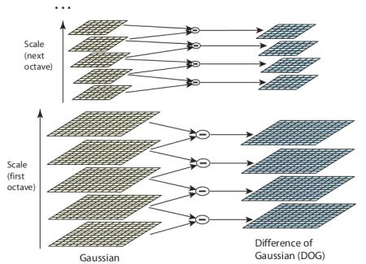

Figure 3.1 SIFT Gaussian Pyramid

Once this DoGare found, images are searched for local extrema over scale and space. For eg, one pixel in an image is compared with its 8 neighbours as well as 9 pixels in next scale and 9 pixels in previous scales. If it is a local extrema, it is a potential keypoint. It basically means that keypoint is best represented in that scale. It is shown in below image:

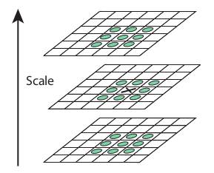

Figure 3.2 SIFT Key point representation

Regarding different parameters, the paper gives some empirical data which can be summarized as, number of octaves = 4, number of scale levels = 5, initial ,  etc as optimal values.

**Step-2 Keypoint Localization**

Once potential keypoints locations are found, one have to be refined to get more accurate results. Taylor series expansion of scale space is used to get more accurate location of extrema, and if the intensity at this extrema is less than a threshold value (0.03 as per the paper), it is rejected. This threshold is called **contrast Threshold** in OpenCV

DoG has higher response for edges, so edges also need to be removed. For this, a concept similar to Harris corner detector is used. A 2x2 Hessian matrix (H) is use to compute the principal curvature. Harris corner detector that for edges, one eigen value is larger than the other. So here use a simple function,

If this ratio is greater than a threshold, called **edge Threshold** in OpenCV, that keypoint is discarded. It is given as 10 in paper.

So it eliminates any low-contrast keypoints and edge keypoints and what remains is strong interest points.

**Step-3 Orientation Assignment**

Now an orientation is assigned to each keypoint to achieve invariance to image rotation. A neighborhood is taken around the keypoint location depending on the scale, and the gradient magnitude and direction is calculated in that region. An orientation histogram with 36 bins covering 360 degrees is created. (It is weighted by gradient magnitude and gaussian-weighted circular window with  equal to 1.5 times the scale of keypoint. The highest peak in the histogram is taken and any peak above 80% of it is also considered to calculate the orientation. It creates keypoints with same location and scale, but different directions. It contribute to stability of matching.

**Step-4 Keypoint Descriptor**

Now keypoint descriptor is created. A 16x16 neighborhood around the keypoint is taken. It is divided into 16 sub-blocks of 4x4 size. For each sub-block, 8 bin orientation histogram is created. So a total of 128 bin values are available. It is represented as a vector to form keypoint descriptor. In addition to this, several measures are taken to achieve robustness against illumination changes, rotation etc.

**Step-5 Keypoint Matching**

Keypoints between two images are matched by identifying their nearest neighbors. But in some cases, the second closest-match may be very near to the first. It may happen due to noise or some other reasons. In that case, ratio of closest-distance to second-closest distance is taken. If it is greater than 0.8, they are rejected. It eliminators around 90% of false matches while discards only 5% correct matches, as per the paper.

So this is a summary of SIFT algorithm. For more details and understanding, reading the original paper is highly recommended. Remember one thing, this algorithm is patented. So this algorithm is included in Non-free module in OpenCV.

**3.2.2 ORIENTED FAST AND ROTATED BRIEF (ORB)**

As an OpenCV enthusiast, the most important thing about the ORB is that it came from “OpenCV Labs”. This algorithm was brought up by Ethan Rublee, Vincent Rabaud, Kurt Konolige and Gary R. Bradski in their paper **ORB: An efficient alternative to SIFT or SURF** in 2011. As the title says, it is a good alternative to SIFT and SURF in computation cost, matching performance and mainly the patents. Yes, SIFT and SURF are patented and you are supposed to pay them for its use. But ORB is not !!!

ORB is basically a fusion of FAST keypoint detector and BRIEF descriptor with many modifications to enhance the performance. First it use FAST to find keypoints, then apply Harris corner measure to find top N points among them. It also use pyramid to produce multiscale-features. But one problem is that, FAST doesn’t compute the orientation. So what about rotation invariance? Authors came up with following modification.

It computes the intensity weighted centroid of the patch with located corner at center. The direction of the vector from this corner point to centroid gives the orientation. To improve the rotation invariance, moments are computed with x and y which should be in a circular region of radius , where  is the size of the patch.

Now for descriptors, ORB use BRIEF descriptors. But already seen that BRIEF performs poorly with rotation. So what ORB does is to “steer” BRIEF according to the orientation of keypoints. For any feature set of  binary tests at location , define a  matrix,  which contains the coordinates of these pixels. Then using the orientation of patch, , its rotation matrix is found and rotates the  to get steered(rotated) version .

ORB discredited the angle to increments of  (12 degrees), and construct a lookup table of pre computed BRIEF patterns. As long as the keypoint orientation  is consistent across views, the correct set of points  will be used to compute its descriptor.

BRIEF has an important property that each bit feature has a large variance and a mean near 0.5. But once it is oriented along keypoint direction, it loses this property and become more distributed. High variance makes a feature more discriminative, since it responds differentially to inputs. Another desirable property is to have the tests uncorrelated, since then each test will contribute to the result. To resolve all these, ORB runs a greedy search among all possible binary tests to find the ones that have both high variance and means close to 0.5, as well as being uncorrelated. The result is called **BRIEF**.

For descriptor matching, multi-probe LSH which improves on the traditional LSH, is used. The paper says ORB is much faster than SURF and SIFT and ORB descriptor works better than SURF. ORB is a good choice in low-power devices for panorama stitching etc.

**3.2.2.1FAST: FAST KEYPOINT ORIENTATION**

FAST features are widely used because of their computational properties. However, FAST features do not have an orientation component. In this section an efficiently computed orientation is added.

**3.2.2.2 FAST DETECTOR**

Start by detecting FAST points in the image. FAST takes one parameter, the intensity threshold between the center pixel and those in a circular ring about the center. FAST-9 (circular radius of 9), which has good performance is used.

FAST does not produce a measure of cornerness, and it has large responses along edges. Employ a Harris corner measure to order the FAST keypoints. For a target number N of keypoints, first set the threshold low enough to get more than N keypoints, then order them according to the Harris measure, and pick the top N points.

FAST does not produce multi-scale features. Employ a scale pyramid of the image, and produce FAST features (filtered by Harris) at each level in the pyramid.

**3.2.2.3. ORIENTATION BY INTENSITY CENTROID**

This approach uses a simple but effective measure of corner orientation, the intensity centroid. Centroid method with two gradient based measures, BIN and MAX is compared. In both cases, X and Y gradients are calculated on a smoothed image. MAX chooses the largest gradient in the keypoint patch; BIN forms a histogram of gradient directions at 10 degree intervals, and picks the maximum bin. BIN is similar to the SIFT algorithm, although it picks only a single orientation. The variance of the orientation in a simulated dataset (in-plane rotation plus added noise). Neither of the gradient measures performs very well, while the centroid gives a uniformly good orientation, even under large image noise.

**3.3 ALGORITHM IMPLEMENTATION**

**3.3.1 SEGMENTATION OF HAND SHAPE**

Extraction of palm pattern ROI includes hand shape segmentation. Previous related work shows that segmentation of colored images result in negative effects. So before segmentation BGR images should be converted into grayscale images. Additionally due to lighting conditions, poor contour images will occur. So an efficient algorithm is implemented to reduce the noisy region. Scale invariant feature transform (SIFT) is used to obtain threshold which is used to segment the hand shape.

**3.3.2 ROI EXTRACTION AND NORMALIZATION**

To extract a ROI from palm pattern image midpoint of palm pattern is taken as reference. A bilinear gray value differential method is used to perform scaling and rotation correction for palm pattern image normalization. The square of the normalization define the palm pattern ROI.

**3.3.3 KEYPOINT DETECTION**

Key points are interest points that are locations of spatial or points in the images that define interesting or stand out points in the image. This is important because n matter how the image changes such as image rotates, strings or distortion key points will remain the same. It is different from the frameworks by describing the key points. Each key point detects an associated descriptor that accompanies it. Key points are detected regardless of orientation and scale but location matters. However to match key points between images then scale and orientation plays a very important role. Only after key points extraction, the information about position and coverage area of the image can be retrieved. Each algorithm has some characteristics to extract key points (they are centered around blobs, edges, corners that are prominent)

**3.3.4 MATCHING IMAGES**

Images are arrays of rows and columns that are arranged as pixels. Each pixel is located in their respective rows and columns. So key points will also share a location of rows and columns. Based on key points that are detected on target palm pattern image and reference palm pattern image, key points are matched based on distance measurement in target image and reference image. Number of key points can be increased or decreased based on image for convenience

Template matching is used to match binary and non binary images however the pattern used in this approach are binary because ROI extracted from contactless palm image will result in deviation of some degree that will affect recognition performance when using template matching on the ROI image.

Matched key points on reference and target images will be identified by drawing lines between the key points. Number of matching key point lines indicates the image matching percentage accuracy.

Percentage matching indicator is displayed as graph of x and y axis from where target images and reference images are compared directly using efficient structural similarity (SSIM). It is an indexed method used for predicting digital images and videos.

SSIM index is a full reference metric based on measurement or prediction of images based on initial uncompressed or distortion free images reference. It is used to improve peak signal to noise ratio and mean square error.

**3.4 SUMMARY**

This chapter deals about Image processing and comprises the details of algorithms used in the label reading system.

**CHAPTER 4**

**SOFTWARE DESCRIPTION**

**4.1 Open CV**

The library has more than 2500 optimized algorithms, which includes a comprehensive set of both classic and state-of-the art computer vision and machine learning algorithms. These algorithms can be used to detect and recognize faces, identify objects, classify human actions in videos, track camera movements, track moving object, extract 3D models of objects, produce 3D point clouds from stereo cameras, stitch images together to produce a high resolution image of an entire scene, find similar images from an image database, remove red eyes from images taken using flash, follow eye movements, recognize scenery and establish markers to overlay it with augmented reality, etc.. OpenCV has more than 47 thousand people of user community and estimated number of downloads exceeding 7 million. The library is used extensively in companies, research groups and by governmental bodies.

Along with well established companies like Google, Yahoo, Microsoft, Intel, IBM, Sony, Honda, Toyota that employ the library, there are many start-ups such as Applied Minds, Video Surf that make extensive use of OpenCV. OpenCV’s deployed uses span the range from stitching street view images together, detecting intrusions in surveillance video in Israel, monitoring mind equipment in China, helping robots navigate and pickup objects at Willow Garage, detection of swimming pool drowning accidents in Europe, running interactive art in Spain and New York, checking runways for debris in Turkey, inspecting labels on products in factories around the world on to rapid face detection in Japan.

It has C++, C, Python, Java and MATLAB interfaces and supports Windows, Linux, Android and Mac OS. OpenCV leans mostly towards real time vision applications and takes advantage of MMX and SSE instructions when available. A full-featured CUDA and OpenCV interfaces are being actively developed right now. There are over 500 algorithms and about 10 times as many functions that compose or support those algorithms. OpenCV is written natively in C++ and has a templated interface that works seamlessly with STL containers.

It was started at Intel in 1999 by Gary Bradsky and the first release came out in 2000. Vadim Pisarevsky joined Gary Bradsky to manage Intel’s Russian software OpenCV team. In 2005, OpenCV was used on Stanley, the vehicle who won 2005 DARPA Grand Challenge. Later its active development continued under the support of Willow Garage, with Gary Bradsky and Vadim Pisarevsky leading the project. Right now, OpenCV supports a lot of algorithms related to Computer Vision and Machine Learning and it is expanding day-by-day. Currently OpenCV supports a wide variety of programming languages like C++, Python, Java etc and is available on different platforms including Windows, Linux, OS X, Android, iOS etc. Also, interfaces based on CUDA and OpenCL are also under active development for high-speed GPU operations. OpenCV-Python is the Python API of OpenCV.

It combines the best qualities of OpenCV C++ API and Python language. OpenCV-Python Python is a general purpose programming language started by Guido van Rossum, which became very popular in short time mainly because of its simplicity and code readability. It enables the programmer to express his ideas in fewer lines of code without reducing any readability. Compared to other languages like C/C++, Python is slower. But another important feature of Python is that it can be easily extended with C/C++. This feature helps us to write computationally intensive codes in C/C++ and create a Python wrapper for it so that use these wrappers as Python modules. This gives two advantages: first, code is as fast as original C/C++ code (since it is the actual C++ code working in background) and second, it is very easy to code in Python. This is how OpenCV-Python works, it is a Python wrapper around original C++ implementation. And the support of Numpy makes the task more easier. Numpy is a highly optimized library for numerical operations. It gives a MATLAB-style syntax.

All the OpenCV array structures are converted to-and-from Numpy arrays. So whatever operations you can do in Numpy, you can combine it with OpenCV, which increases number of weapons in your arsenal. Besides that, several other libraries like SciPy, Matplotlib which supports Numpy can be used with this. So OpenCV-Python is an appropriate tool for fast prototyping of computer vision problems.

**4.1.1 Cross platform**

OpenCV was designed to be cross-platform. So, the library was written in C and this makes OpenCV portable to almost any commercial systems, from PowerPC Macs to robotic dogs. Since version 2.0, OpenCV includes its traditional C interface as well as the new C++ one. For the most part, new OpenCV algorithms are developed in C++. Also wrappers for languages such as Python and Java have been developed to encourage adoption by a wider audience. OpenCV runs on both desktop(Windows, Linux, Android, MacOS, FreeBSD, OpenBSD) and mobile(Android, Maemo, iOS).

**4.1.2 Applications**

OpenCV’s application areas include:

* 2D and 3D feature toolkit
* Ego motion estimation
* Facial recognition system
* Random forest

**4.2 PYTHON**

Python is widely used high-level, general-purpose, interpreted, dynamic programming language. Its design philosophy emphasizes code readability, and its syntax allows programmers to express concepts in fewer lines of code than would be possible in languages such as C++, Java. The language provides constructs intended to enable clear programs on both a small and large scale.

Python supports multiple programming paradigms, including object oriented, imperative, functional programming or procedural styles. It features a dynamic type system and automatic memory management and has a large and comprehensive standard library.

Python interpreters are available for installation on many operating systems, allowing Python code execution on a wide variety of systems. Using [third-party](https://en.wikipedia.org/wiki/Third-party_software_component) tools, such as [Py2exe](https://en.wikipedia.org/wiki/Py2exe) or Py installer, Python code can be packaged into stand-alone executable programs for some of the most popular operating systems, allowing the distribution of Python-based software for use on those environments without requiring the installation of a Python interpreter. [CPython](https://en.wikipedia.org/wiki/CPython), the [reference implementation](https://en.wikipedia.org/wiki/Reference_implementation) of Python, is [free and open-source software](https://en.wikipedia.org/wiki/Free_and_open-source_software) and has a community-based development model, as do nearly all of its alternative implementations. CPython is managed by the non-profit Python Software Foundation.

Python is a multi-paradigm programming language: Object-Oriented and Structured Programming are fully supported, and many language feature support functional programming and aspect-oriented programming (including by meta programming and meta objects (magic methods)). Many other paradigms are supported via extensions, including design by contract and logic programming. Python uses dynamic typing and a mix of reference counting and a cycle-detecting garbage collector for memory management. An important feature of Python is dynamic name resolution (late binding), which binds method and variable names during program execution.

**4.3 Open CV - Python**

Python is a general purpose programming language started by Guido van Rossum, which became very popular in short time mainly because of its simplicity and code readability. It enables the programmer to express his ideas in fewer lines of code without reducing any readability.

Compared to other languages like C/C++, Python is slower. But another important feature of Python is that it can be easily extended with C/C++. This feature helps us to write computationally intensive codes in C/C++ and create a Python wrapper for it so that use these wrappers as Python modules. This gives us two advantages: first, code is as fast as original C/C++ code (since it is the actual C++ code working in background) and second, it is very easy to code in Python. This is how OpenCV-Python works, it is a Python wrapper around original C++ implementation.

And the support of Numpy makes the task more easier. Numpy is a highly optimized library for numerical operations. It gives a MATLAB-style syntax. All the OpenCV array structures are converted to-and-from Numpy arrays. So whatever operations you can do in Numpy, you can combine it with OpenCV, which increases number of weapons in your arsenal. Besides that, several other libraries like SciPy, Matplotlib which supports Numpy can be used with this.

So OpenCV-Python is an appropriate tool for fast prototyping of computer vision problems.

**4.4 INSTALL Open CV-PYTHON IN WINDOWS**

**4.4.1 INSTALLING Open CV FROM PREBUILT BINARIES**

1. Below Python packages are to be downloaded and installed to their default locations.

1.1. Python-2.7.x.

1.2. Numpy.

1.3. Matplotlib (Matplotlib is optional).

2. Install all packages into their default locations. Python will be installed to C:/Python27/.

3. After installation, open Python IDLE. Enter import numpy and make sure Numpy is working fine.

4. Download latest OpenCV release from source forge site and double-click to extract it.

5. Go to opencv/build/python/2.7 folder.

6. Copy cv2.pyd to C:/Python27/lib/site-packeges.

7. Open Python IDLE and type following codes in Python terminal.

>>> import cv2

>>> print cv2.__version__

**4.4.2 BUILDING Open CV FROM SOURCE**

1. Download and install Visual Studio and CMake.

1.1. Visual Studio 2012

1.2. CMake

2. Download and install necessary Python packages to their default locations

2.1. Python 2.7.x

2.2. Numpy

2.3. Matplotlib

3. Make sure Python and Numpy are working fine.

4. Download OpenCV source. It can be from Source forge (for official release version) or from Github (for latestsource).

5. Extract it to a folder, opencv and create a new folder build in it.

6. Open CMake-gui (Start > All Programs >CMake-gui)

7. Fill the fields as follows (see the image below):

7.1. Click on Browse Source... and locate the opencv folder.

7.2. Click on Browse Build... and locate the build folder.

7.3. Click on Configure.



Figure 4.1 Filling the fields

7.4. It will open a new window to select the compiler. Choose appropriate compiler (here, Visual Studio 11) and click Finish.



Figure 4.2 Selecting a compiler

7.5. Wait until analysis is finished.

8. You will see all the fields are marked in red. Click on the WITH field to expand it. It decides what extra features you need. So mark appropriate fields. See the below image:



Figure 4.3 Selecting appropriate WITH fields

9. Now click on BUILD field to expand it. First few fields configure the build method. See the below image:



Figure 4.4 Selecting BUILD fields

10. Remaining fields specify what modules are to be built. Since GPU modules are not yet supported by Open CV Python, you can completely avoid it to save time (But if you work with them, keep it there). See the image below:



Figure 4.5 Selecting the required fields for Open CV

11. Now click on ENABLE field to expand it. Make sure ENABLE_SOLUTION_FOLDERS is unchecked (Solution folders are not supported by Visual Studio Express edition). See the image below:



Figure 4.6 Selecting ENABLE fields

12. Also make sure that in the PYTHON field, everything is filled. (Ignore PYTHON_DEBUG_LIBRARY). See image below:



Figure 4.7 Filled PYTHON field

13. Finally click the Generate button.

14. Now go to opencv/build folder. There you will find OpenCV.sln file. Open it with Visual Studio.

15. Check build mode as Release instead of Debug.

16. In the solution explorer, right-click on the Solution (or ALL_BUILD) and build it. It will take some time to finish.

17. Again, right-click on INSTALL and build it. Now OpenCV-Python will be installed.



Figure 4.8 Installing Open CV- Python

18. Open Python IDLE and enter import cv2. If no error, it is installed correctly

**4.5 SIFT IN Open CV**

So now let’s see SIFT functionalities available in OpenCV. Let’s start with keypoint detection and draw them. First construct a SIFT object. Pass different parameters to it which are optional and they are well explained in docs.

import cv2

import numpy as np

img = cv2.imread('home.jpg')

gray= cv2.cvtColor(img,cv2.COLOR_BGR2GRAY)

sift = cv2.SIFT()

kp = sift.detect(gray,None)

img=cv2.drawKeypoints(gray,kp)

cv2.imwrite('sift_keypoints.jpg',img)

sift.detect() function finds the keypoint in the images. You can pass a mask if you want to search only a part of image. Each keypoint is a special structure which has many attributes like its (x,y) coordinates, size of the meaningful neighborhood, angle which specifies its orientation, response that specifies strength of keypoints etc.

OpenCV also provides cv2.drawKeyPoints() function which draws the small circles on the locations of keypoints. If you pass a flag, v2.DRAW_MATCHES_FLAGS_DRAW_RICH_KEYPOINTS to it, it will draw a circle with size of keypoint and it will even show its orientation. See below example.

img=cv2.drawKeypoints(gray,kp,flags=cv2.DRAW_MATCHES_FLAG S_DRAW_RICH_KEYPOINTS)

cv2.imwrite('sift_keypoints.jpg',img)

See the two results below:



Figure 4.9 Key points detection in SIFT

Now to calculate the descriptor, OpenCV provides two methods.

1. Since you already found keypoints, you can call sift.compute() which computes the descriptors from the keypoints.

Eg: kp,des = sift.compute(gray,kp)

2. If you didn’t find keypoints, directly find keypoints and descriptors in a single step with the function,sift.detectAndCompute().

Second method:

sift = cv2.SIFT()

kp, des = sift.detectAndCompute(gray,None)

Here kp will be a list of keypoints and des is a numpy array of shape 𝑁𝑢𝑚𝑏𝑒𝑟_𝑜𝑓_𝐾𝑒𝑦𝑝𝑜𝑖𝑛𝑡𝑠× 128.

**4.6ORB in Open CV**

As usual, create an ORB object with the function, cv2.ORB() or using feature2d common interface. It has a number of optional parameters. Most useful ones are nFeatures which denotes maximum number of features to be retained (by default 500), scoreType which denotes whether Harris score or FAST score to rank the features (by default, Harris score) etc. Another parameter, WTA_K decides number of points that produce each element of the oriented BRIEF descriptor. By default it is two, i.e selects two points at a time. In that case, for matching, NORM_HAMMING distance is used. If WTA_K is 3 or 4, which takes 3 or 4 points to produce BRIEF descriptor, then matching distance is defined by NORM_HAMMING2.

Below is a simple code which shows the use of ORB.

Import numpy as np

import cv2

frommatplotlib import pyplotas plt

img = cv2.imread('simple.jpg',0)

orb = cv2.ORB()

kp = orb.detect(img,None)

kp, des = orb.compute(img, kp)

img2 = cv2.drawKeypoints(img,kp,color=(0,255,0), flags=0)

plt.imshow(img2),plt.show()

See the result below:



Figure 4.10 Key point detection in ORB

**4.7 SUMMARY**

This chapter deals about the programming languages used in the project. OpenCV, Python are the programming platforms. The code which is loaded into the Raspberry Pi is executed based on the programming condition.

**CHAPTER 5**

**EXPERIMENTAL RESULTS**

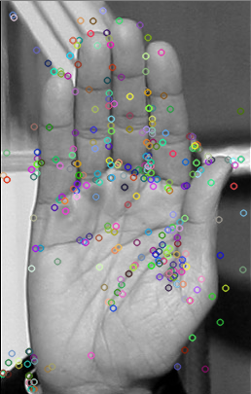

Keypoint detection

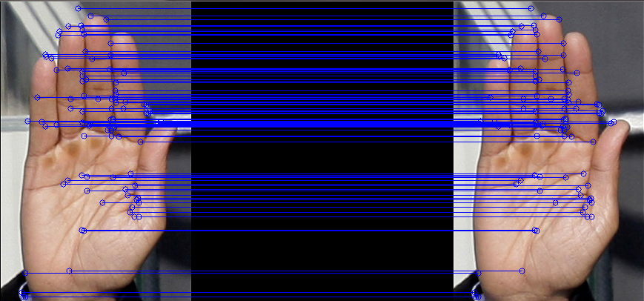

Key point matching based on distance measurement

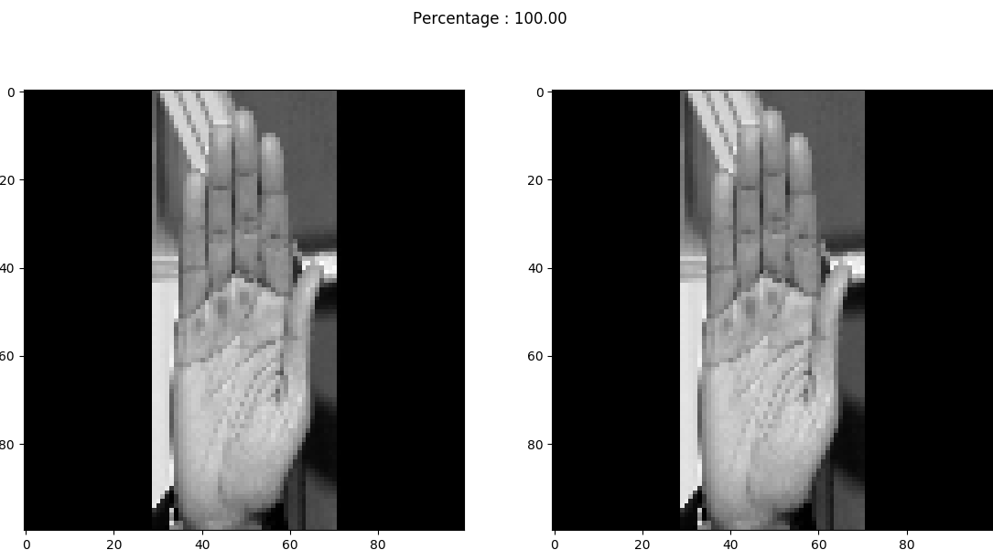

Percentage Matching Indication

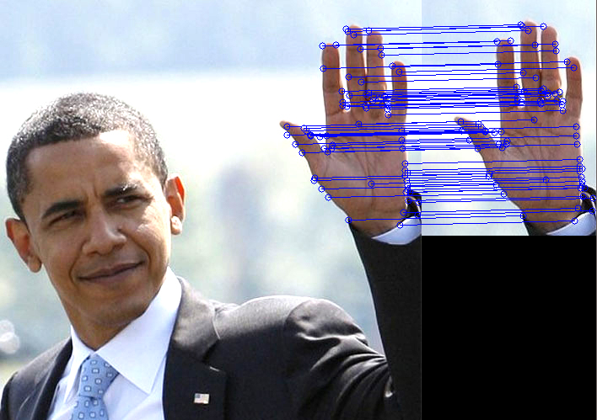

SIFT output for image 1

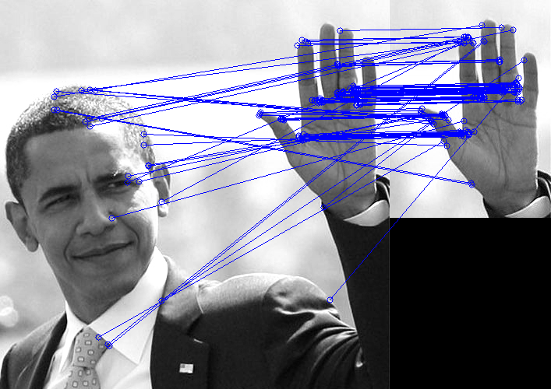

ORB output for image 1

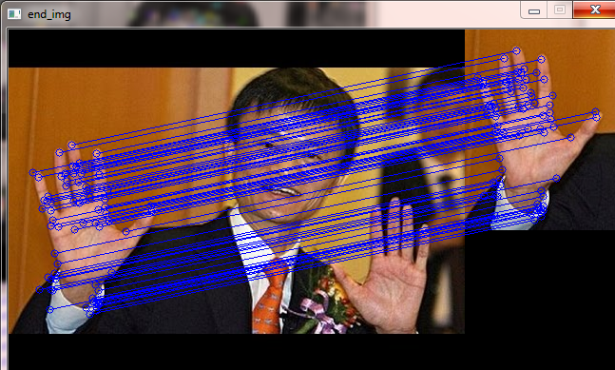

SIFT output for image 2

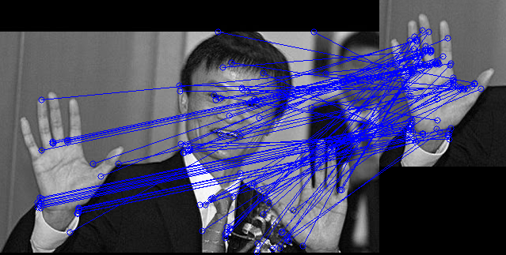

ORB output for image 2

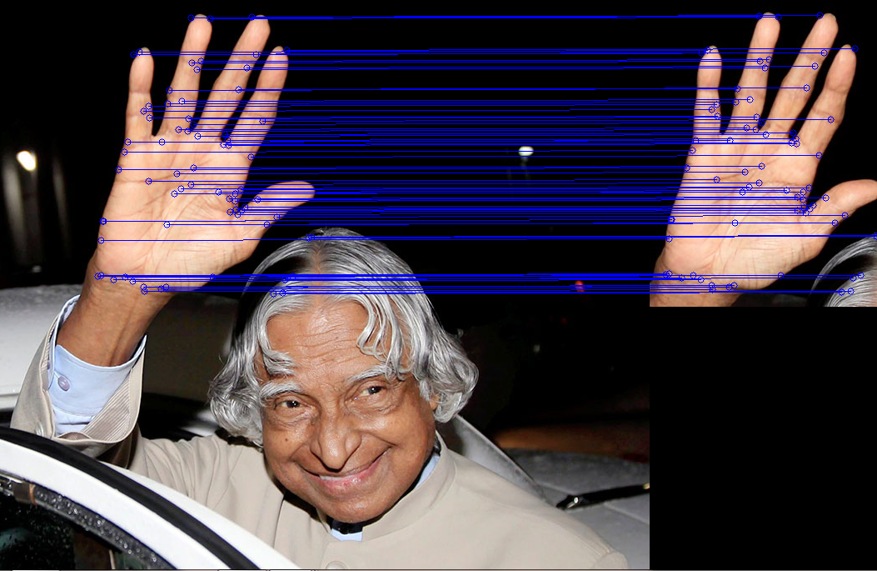

SIFT output for image 3

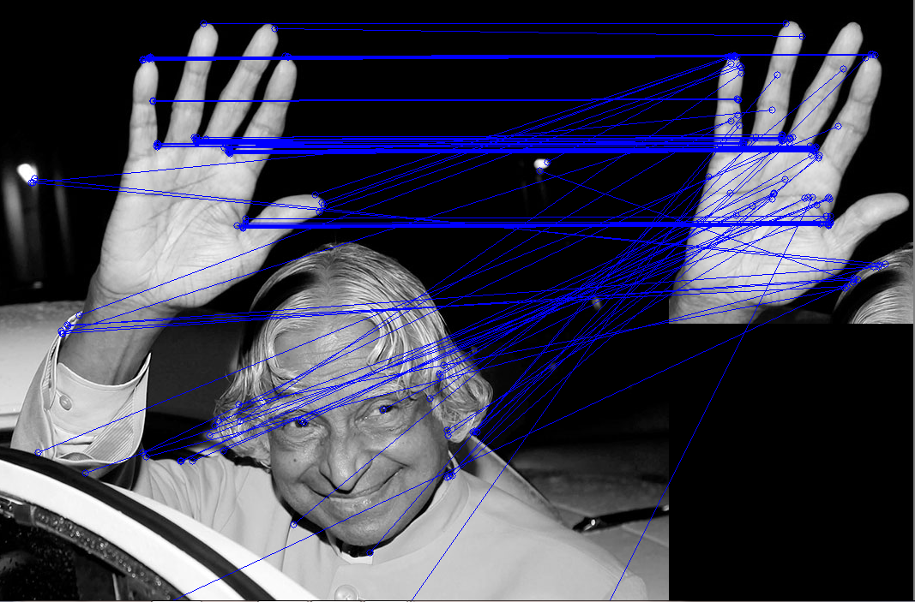

ORB output for image 3

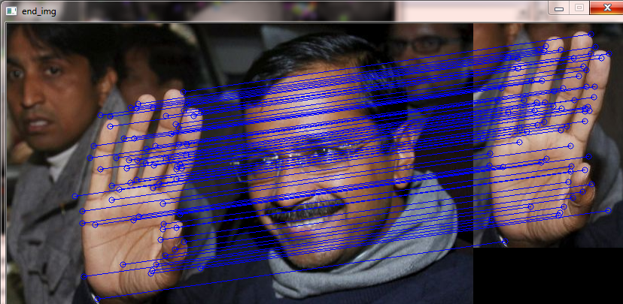

SIFT output for image 4

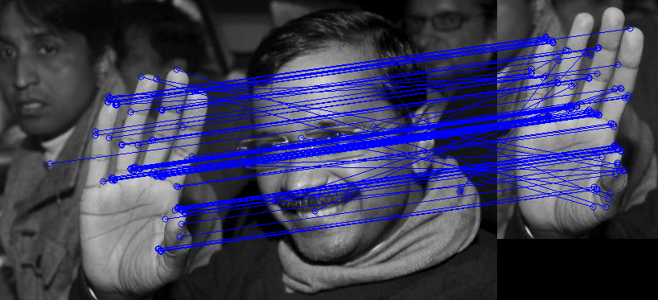

ORB output for image 4

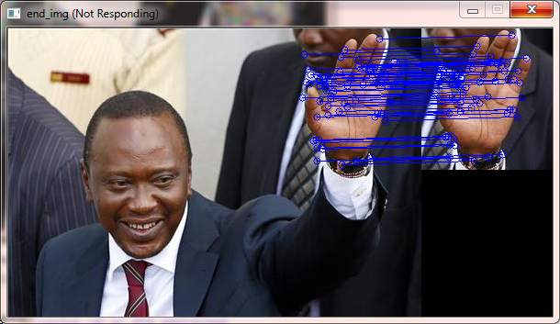

SIFT output for image 5

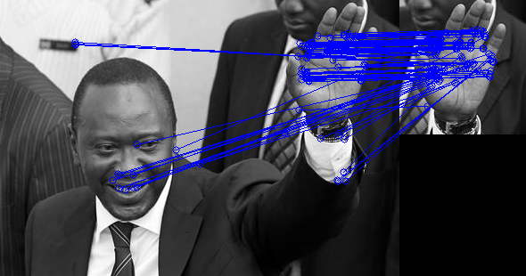

ORB output for image 5

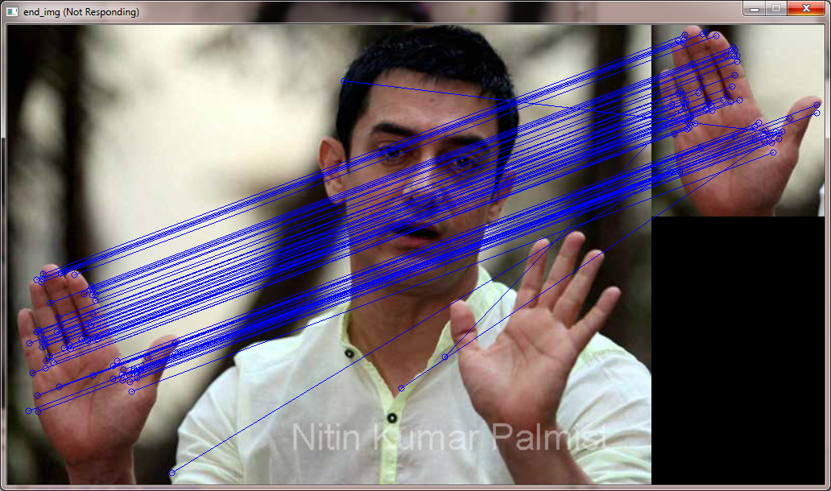

SIFT output for image 6

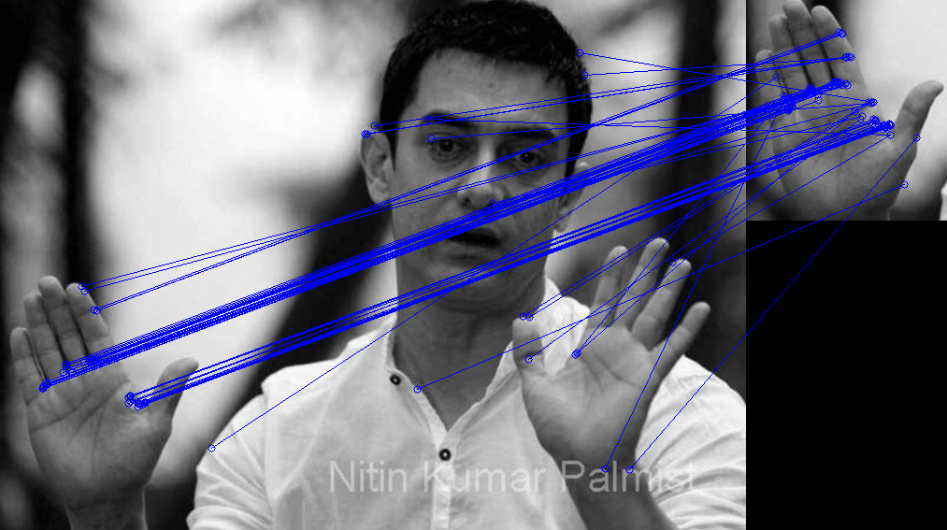

ORB output for image 6

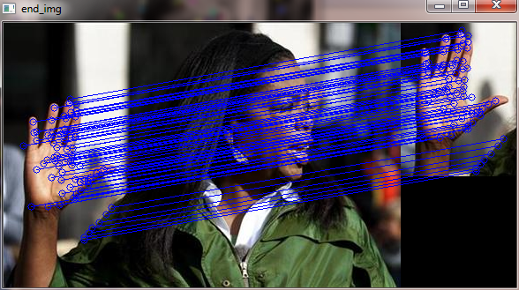

SIFT output for image 7

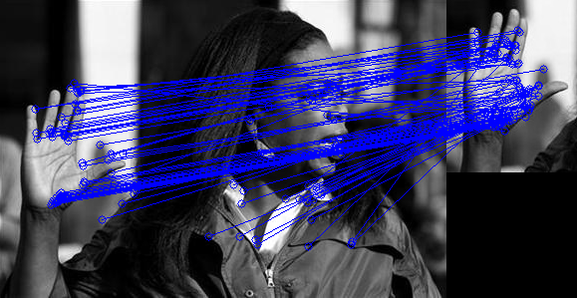

ORB output for image 7

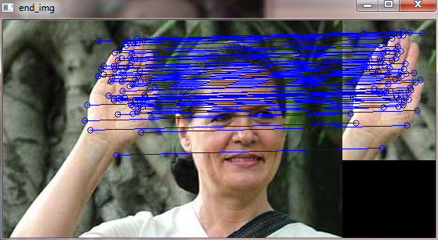

SIFT output for image 8

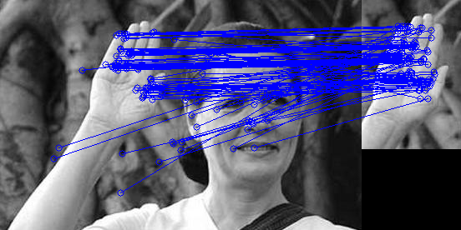

ORB output for image 8

**CHAPTER 6**

**CONCLUSION AND FUTURE WORK**

**CONCLUSION**

Numerous studies have reveal that SIFT algorithm applied on palm pattern image has high accuracy due to its higher texture representation ability and high computational burden. Comparative experiments and results demonstrated that oriented FAST and rotated BRIEF have low computational burden as compared with SIFT. However when operated on entire image it cannot be applied on real time images. Therefore our method can be extended to palm pattern recognition and achieve greater performance after employing SIFT strategy using some extended techniques to reduce the high computational burden. Our proposed method focus on contactless palm pattern images that is suitable for real world scenarios.

**FUTURE WORK**

Future implementation of this project will be real time implementation of palm pattern recognition. For real time implementation, IR rays scanner is used for scanning palm pattern of each individual. Since it is used as biometric identification, it can be implemented in all places that needed more security like bank lockers, houses, offices, and for access to confidential places. During real time implementation, databases of authorized persons are maintained with high accuracy. This database usually needed to process faster and must compare with target palm pattern images within a limited amount of time. For that SIFT algorithm needs to be patented and also need to be in more optimized form. Since SIFT impose high computational burden, the size of the images need to be minimized without compromising the quality of the palm patterns. This concept will have great future in biometrics if it is implemented in real time in more optimized form and less computational time.

**REFERENCES**

|  |  |
| --- | --- |
| [1] | SaharBayoumi, R. M. Bolle, and S. Pankanti, *Biometrics: Personal Identificationin Networked Society*. Norwell, MA, USA: Kluwer, 1999. |
| [2] | Y. Hao, S. Zhao, and J. Liu, “Local derivative pattern versus  local binary pattern: Face recognition with high-order local pattern  descriptor,” *IEEE Trans. Image Process.*, vol. 19, no. 2, pp. 533–544,  Feb. 2010. |
| [3] | Y. Zhou and A. Kumar, “Human identification using palm-vein images,”  *IEEE Trans. Inf. Forensics Security*, vol. 6, no. 4, pp. 1259–1274,  Dec. 2011. |
| [4] | Z. Khan, A. Mian, and Y. Hu, “Contour code: Robust and efficient  multispectral palmprint encoding for human recognition,” in *Proc. IEEE*  *Int. Conf. Comput. Vis.*, Nov. 2011, pp. 1935–1942. |
| [5] | L. Zhang, L. Zhang, and D. Zhang, “Finger-knuckle-print verification  based on band-limited phase-only correlation,” in *Proc. 13th Int. Conf.*  *Comput. Anal. Images Patterns*, 2009, pp. 141–148. |
| [6] | L. Mirmohamadsadeghi and A. Drygajlo, “Palm vein recognition with  local binary patterns and local derivative patterns,” in *Proc. Int. Joint*  *Conf. Biometrics*, Oct. 2011, pp. 1–6. |
| [7] | J.-C. Lee, “A novel biometric system based on palm vein image,” *Pattern*  *Recognit. Lett.*, vol. 33, no. 12, pp. 1520–1528, Sep. 2012. |
| [8] | Z. Liu, Y. Yin, H. Wang, S. Song, and Q. Li, “Finger vein recognition  with manifold learning,” *J. Netw. Comput. Appl.*, vol. 33, no. 3, pp. 275–282, 2010. |
| [9] | J.-G. Wang, W.-Y. Yau, A. Suwandy, and E. Sung, “Person recognition  by fusing palmprint and palm vein images based on ‘Laplacianpalm’ representation,”*PatternRecognit.*, vol. 41, no. 5, pp. 1514–1527, May 2008. |
| [10] | G. Yang, X. Xi, and Y. Yin, “Finger vein recognition based on (2D)2  PCA and metric learning,” *J. Biomed. Biotechnol.*, vol. 2012, pp. 1–9,  Mar. 2012, Art. ID 324249. |
| [11] | T. Ahonen, A. Hadid, and M. Pietikainen, “Face description with  local binary patterns: Application to face recognition,” *IEEE Trans.*  *Pattern Anal. Mach. Intell.*, vol. 28, no. 12, pp. 2037–2041,Dec. 2006. |
| [12] | Y. He, G. Feng, Y. Hou, L. Li, and E. Micheli-Tzanakou, “Iris feature  extraction method based on LBP and chunked encoding,” in *Proc. 7th*  *Int. Conf. Natural Comput.*, Jul. 2011, pp. 1663–1667. |
| [13] | V. Kellokumpu, G. Zhao, S. Z. Li, and M. Pietikäinen, “Dynamic texture  based gait recognition,” in *Proc. 3rd Int. Conf. Adv. Biometrics*, 2009,  pp. 1000–1009. |
| [14] | W. Zhao, R. Chellappa, P. J. Phillips, and A. Rosenfeld, “Face recognition:  A literature survey,” *ACM Comput. Surv.*, vol. 35, no. 4,  pp. 399–458, 2003. |
| [15] | N. Otsu, “A threshold selection method from gray-level histograms,”  *Automatica*, vol. 11, nos. 285–296, pp. 23–27, 1975. |
| [16] | M. G. K. Ong, T. Connie, A. T. B. Jin, and D. N. C. Ling,  “A single-sensor hand geometry and palmprint verification system,”  in *Proc. ACM SIGMM Workshop Biometrics Methods Appl.*, 2003,  pp. 100–106. |
| [17] | J. H. Choi, W. Song, T. Kim, S.-R. Lee, and H. C. Kim, “Finger vein  extraction using gradient normalization and principal curvature,” *Proc.*  *SPIE*, vol. 7251, p. 725111, Feb. 2009. |
| [18] | W. Song, “Finger-vein identification system using level set curvature,”  M.S. thesis, Dept. Comput. Sci. Elect. Eng., Seoul National Univ., Seoul,  Korea, 2008. |
| [19] | G. Aubert and P. Kornprobst, *Mathematical Problems in Image Processing:Partial Differential Equations and the Calculus of Variations*.  New York, NY, USA: Springer-Verlag, 2006. |
| [20] | K. Ito, H. Nakajima, K. Kobayashi, T. Aoki, and T. Higuchi,  “A fingerprint matching algorithm using phase-only correlation,” *IEICE*  *Trans. Fundam. Electron.,Commun., Comput. Sci.*, vol. E87-A, no. 3,  pp. 682–691, 2004. |
|  |  |

**APPENDIX**

**Scale Invariant Feature Transform**

importnumpy as np

import cv2

import time

img1 = cv2.imread('dataset\obama.jpg',cv2.IMREAD_COLOR)

img2 = cv2.imread('dataset1\obama1.jpg',cv2.IMREAD_COLOR)

gray1 = cv2.cvtColor(img1, cv2.COLOR_BGR2GRAY)

gray2 = cv2.cvtColor(img2, cv2.COLOR_BGR2GRAY)

#SIFT

detector = cv2.SIFT()

keypoints1 = detector.detect(gray1, None)

keypoints2 = detector.detect(gray2, None)

outimg1 = cv2.drawKeypoints(gray1, keypoints1)

outimg2 = cv2.drawKeypoints(gray2, keypoints2)

cv2.imshow('img1', outimg1)

cv2.imshow('img2', outimg2)

#kp,des = sift.compute(gray,kp)

kp1, des1 = detector.compute(gray1, keypoints1)

kp2, des2 = detector.compute(gray2, keypoints2)

print kp1

print kp2

print des1

print des2

matcher = cv2.BFMatcher()

matches = matcher.match(des1, des2)

matches = sorted(matches, key = lambda x:x.distance)

print matches

print "Length of matches :",len(matches)

defdrawMatches(img1, kp1, img2, kp2, matches):

rows1 = img1.shape[0]

cols1 = img1.shape[1]

rows2 = img2.shape[0]

cols2 = img2.shape[1]

out = np.zeros((max([rows1,rows2]),cols1+cols2,3), dtype='uint8')

out[:rows1, :cols1] = np.dstack([img1])

out[:rows2, cols1:] = np.dstack([img2])

img1_idx = mat.queryIdx

img2_idx = mat.trainIdx

(x1,y1) = kp1[img1_idx].pt

(x2,y2) = kp2[img2_idx].pt

print "length of x1",x1

cv2.circle(out, (int(x1),int(y1)), 4, (255, 0, 0), 1)

cv2.circle(out, (int(x2)+cols1,int(y2)), 4, (255, 0, 0), 1)

cv2.line(out, (int(x1),int(y1)), (int(x2)+cols1,int(y2)), (255, 0, 0), 1)

#cv2.imshow('Matched Features',out)

#cv2.waitKey(0)

#cv2.destroyWindow('Matched Features')

return out

end_img = drawMatches(img1, kp1, img2, kp2, matches[:75])

cv2.imshow('end_img', end_img)

cv2.waitKey(100)

#cv2.destroyAllWindows()

**Oriented FAST and Rotated BRIEF**

importnumpy as np

import cv2

defdrawMatches(img1, kp1, img2, kp2, matches):

# Create a new output image that concatenates the two images together

# (a.k.a) a montage

rows1 = img1.shape[0]

cols1 = img1.shape[1]

rows2 = img2.shape[0]

cols2 = img2.shape[1]

out = np.zeros((max([rows1,rows2]),cols1+cols2,3), dtype='uint8')

# Place the first image to the left

out[:rows1,:cols1] = np.dstack([img1, img1, img1])

# Place the next image to the right of it

out[:rows2,cols1:] = np.dstack([img2, img2, img2])

# For each pair of points between both images

# draw circles, then connect a line between them

for mat in matches:

# Get the matching keypoints for each of the images

img1_idx = mat.queryIdx

img2_idx = mat.trainIdx

# x - columns

# y - rows

(x1,y1) = kp1[img1_idx].pt

(x2,y2) = kp2[img2_idx].pt

# Draw a small circle at both co-ordinates

# radius 4

# colour blue

# thickness = 1

cv2.circle(out, (int(x1),int(y1)), 4, (255, 0, 0), 1)

cv2.circle(out, (int(x2)+cols1,int(y2)), 4, (255, 0, 0), 1)

# Draw a line in between the two points

# thickness = 1

# colour blue

cv2.line(out, (int(x1),int(y1)), (int(x2)+cols1,int(y2)), (255, 0, 0), 1)

# Show the image

cv2.imshow('Matched Features', out)

cv2.waitKey(0)

cv2.destroyWindow('Matched Features')

# Also return the image if you'd like a copy

return out

img1 = cv2.imread('dataset\obama.jpg', 0) # Original image - ensure grayscale

img2 = cv2.imread('dataset1\obama1.jpg', 0) # Rotated image - ensure grayscale

# Create ORB detector with 1000 keypoints with a scaling pyramid factor

# of 1.2

orb = cv2.ORB(1000, 1.2)

# Detectkeypoints of original image

(kp1,des1) = orb.detectAndCompute(img1, None)

(kp2,des2) = orb.detectAndCompute(img2, None)

bf = cv2.BFMatcher(cv2.NORM_HAMMING, crossCheck=True)

matches = bf.match(des1,des2)

matches = sorted(matches, key=lambda val: val.distance)

out = drawMatches(img1, kp1, img2, kp2, matches[:100])

**IMAGE MATCHER**

importTkinter as Tk

fromskimage.measure import structural_similarity as ssim

img1 = cv2.imread("dataset\xi.jpg")

img2 = cv2.imread("dataset1\xi.png")

img11 = cv2.cvtColor(img1, cv2.COLOR_BGR2GRAY)

img12 = cv2.cvtColor(img2, cv2.COLOR_BGR2GRAY)

imageA = cv2.resize(img11, (100, 100))

imageB = cv2.resize(img12, (100, 100))

s = ssim(imageA, imageB)

fig = plt.figure("_Result_")

if s<0:

s=0

plt.suptitle("Percentage : %.2f " % (s*100))

ax = fig.add_subplot(1, 2, 1)

plt.imshow(imageA, cmap = plt.cm.gray)

#plt.axis("off")

ax = fig.add_subplot(1, 2, 2)

plt.imshow(imageB, cmap = plt.cm.gray)

#plt.axis("off")

plt.show()